4. Results

4.1 Experimental configuration
The benchmark contained 20 configurations: 2 network types × 5 data volumes (T = 50, 100, 150, 200, 250) × 2 noise levels (σ = 0.1, 0.5). Each configuration was replicated 5 times, giving 100 experiments. All experiments used 100 KRI time series, a VAR(1) DGP with Student’s t-copula tail dependence (ν = 5), and 13-period DebtRank propagation. Four methods were evaluated: VAR+DY, CoVaR, GNN, and DebtRank. Recovery estimators were scored on precision, recall, F1, AUC-ROC, and AUPRC; DebtRank was scored only on impulse-response MSE (IR-MSE).

4.2 Direction-identifiability diagnostic
Across three replications, 15.4% of W_true’s 39 directed edges were recoverable from lag-1 partial correlations at the PRT level. The diagnostic returned direction_identifiable = false. This is a pre-recovery constraint on lag-based recovery and frames the AUC-ROC results below.

4.3 AUC-ROC
Table 4.2 reports AUC-ROC by estimator and network type.
Table 4.2 — AUC-ROC by estimator and network type
Method | Designed | Random | Difference
VAR+DY | 0.4998 | 0.5007 | −0.0010
CoVaR | 0.5982 | 0.7025 | −0.1043
GNN | 0.2658 | 0.3639 | −0.0981
VAR+DY is at chance on both network types: 0.4998 designed and 0.5007 random. CoVaR is above chance on both: 0.5982 designed and 0.7025 random. GNN is below chance on both: 0.2658 designed and 0.3639 random.
Insert Figure 4.1 here. Insert Figure 4.2 here.
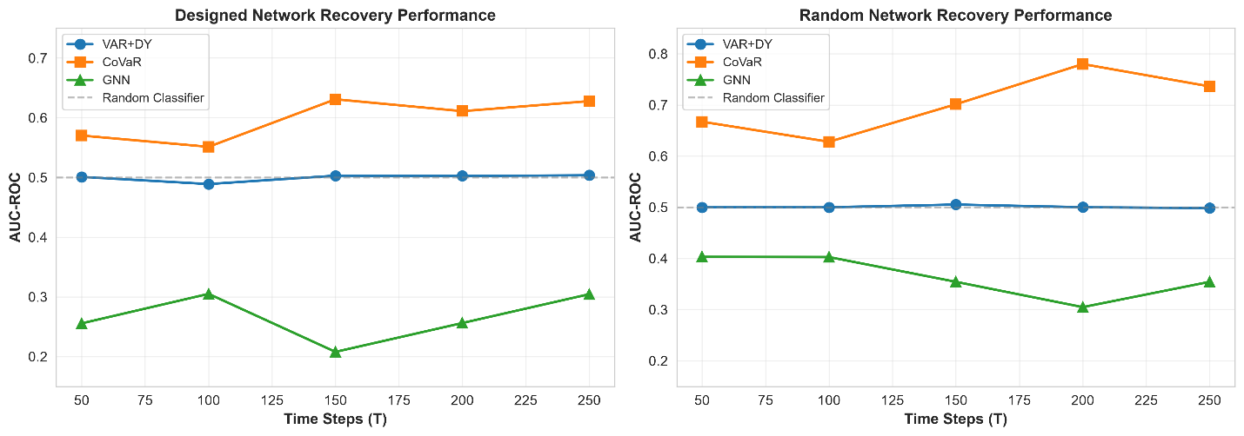
Figure 4.1. AUC-ROC versus time steps for VAR+DY, CoVaR, and GNN on designed and random networks. Dashed line is random-classifier baseline (AUC = 0.50).
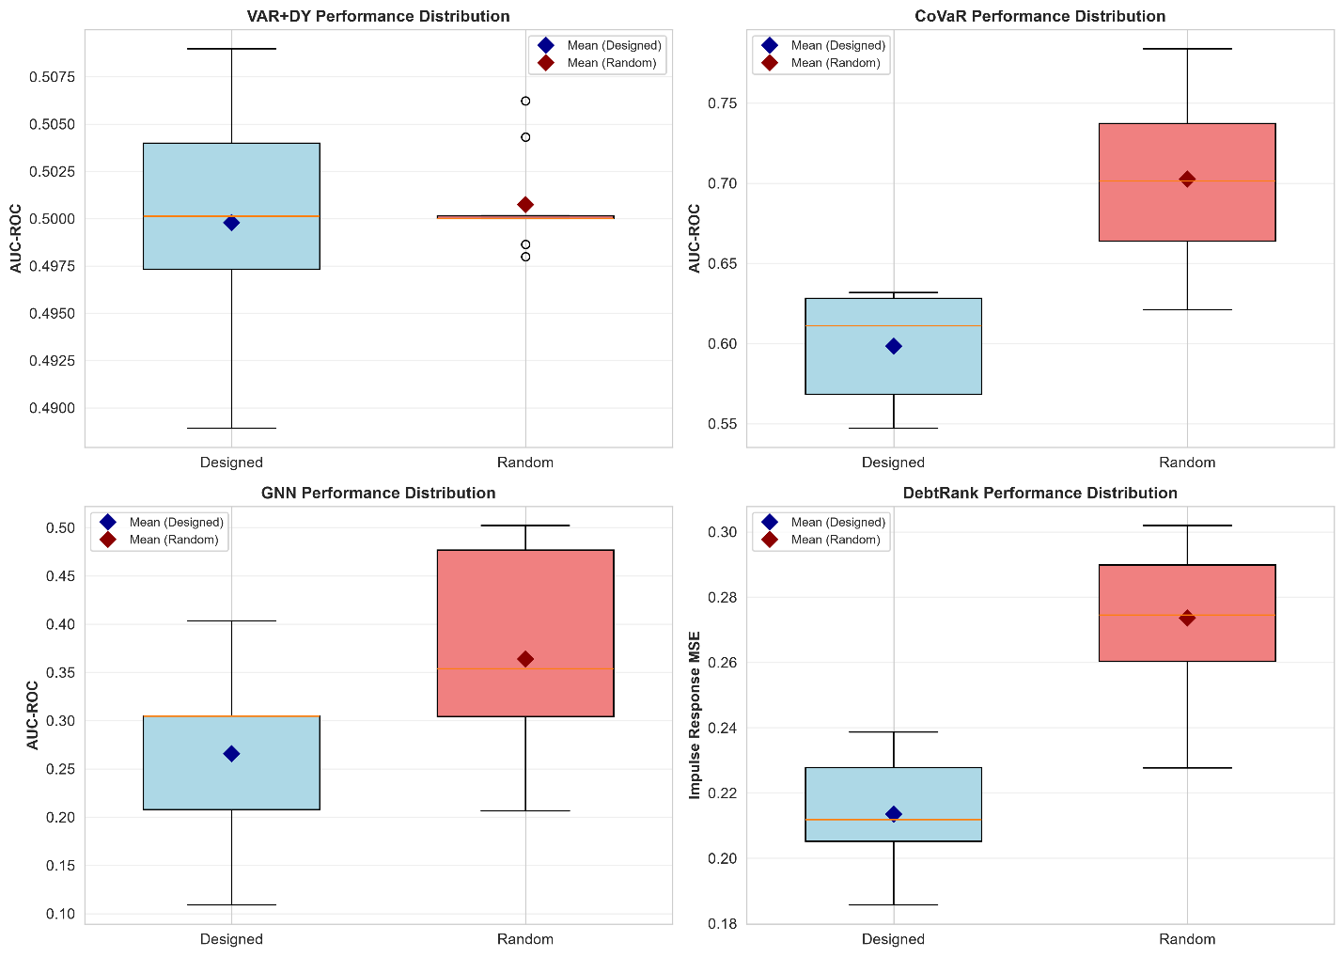
Figure 4.2. Designed versus random performance distributions: AUC-ROC for VAR+DY, CoVaR, and GNN; IR-MSE for DebtRank.

4.4 Classification metrics
Table 4.3 reports precision, recall, and F1 at optimal thresholds.
Table 4.3 — Precision, recall, and F1 by estimator and network type
Method | Designed precision | Designed recall | Designed F1 | Random precision | Random recall | Random F1
VAR+DY | 0.0975 | 1.0000 | 0.1777 | 0.0700 | 1.0000 | 0.1308
CoVaR | 0.1439 | 0.5208 | 0.2160 | 0.1630 | 0.4661 | 0.2408
GNN | 0.0981 | 1.0000 | 0.1786 | 0.0703 | 1.0000 | 0.1314
VAR+DY and GNN both classify every candidate edge as positive at their optimal thresholds: recall = 1.0000 in both network types, precision approximately equal to the positive base rate, and F1 equal to the predict-all baseline. CoVaR is the only estimator producing sparse predictions: recall 0.5208 designed and 0.4661 random; precision 0.1439 designed and 0.1630 random; F1 0.2160 designed and 0.2408 random.
Insert Figure 4.3 here.
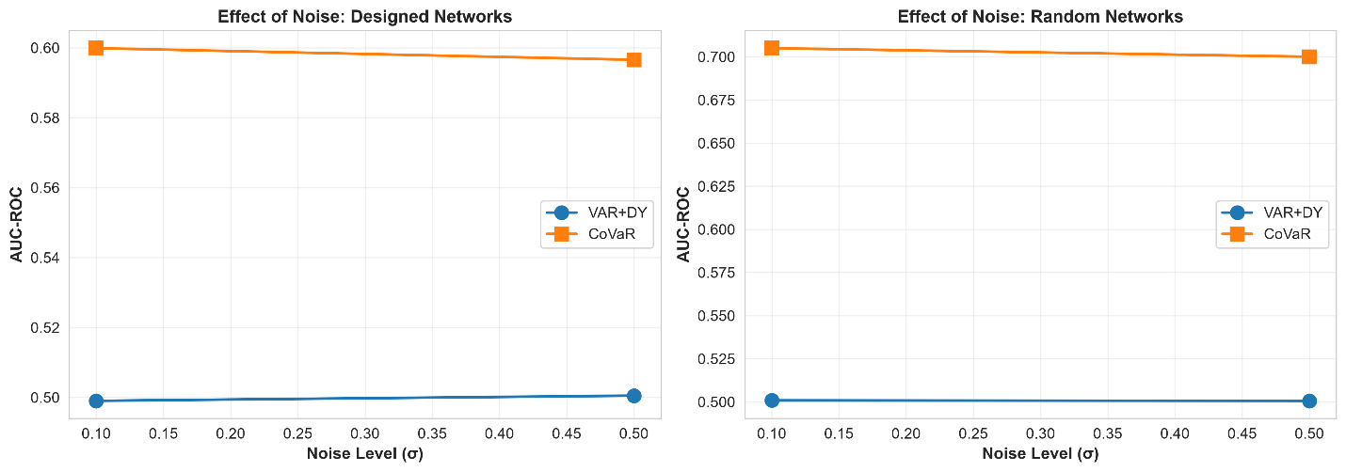
Figure 4.3. Effect of noise level (σ = 0.1, 0.5) on AUC-ROC for VAR+DY and CoVaR on designed and random networks.

4.5 AUPRC and the GNN divergence
For GNN, AUPRC was 0.5490 designed and 0.5352 random, above the positive-class baseline of approximately 0.10, while its AUC-ROC was below chance (0.2658 designed, 0.3639 random). We report this divergence as produced by the evaluation code and do not interpret it in §4.

4.6 DebtRank IR-MSE
DebtRank was evaluated only on IR-MSE against the reference cascade.
Table 4.5 — DebtRank IR-MSE by network type
Network type | Mean IR-MSE | Std dev
Designed (W_true) | 0.2135 | 0.0174
Random (Erdős–Rényi) | 0.2736 | 0.0228
Designed-network IR-MSE is 22.0% lower than random-network IR-MSE (0.2135 vs 0.2736). This is the only metric in the study on which the designed network outperforms random networks.
Insert Figure 4.5 here.
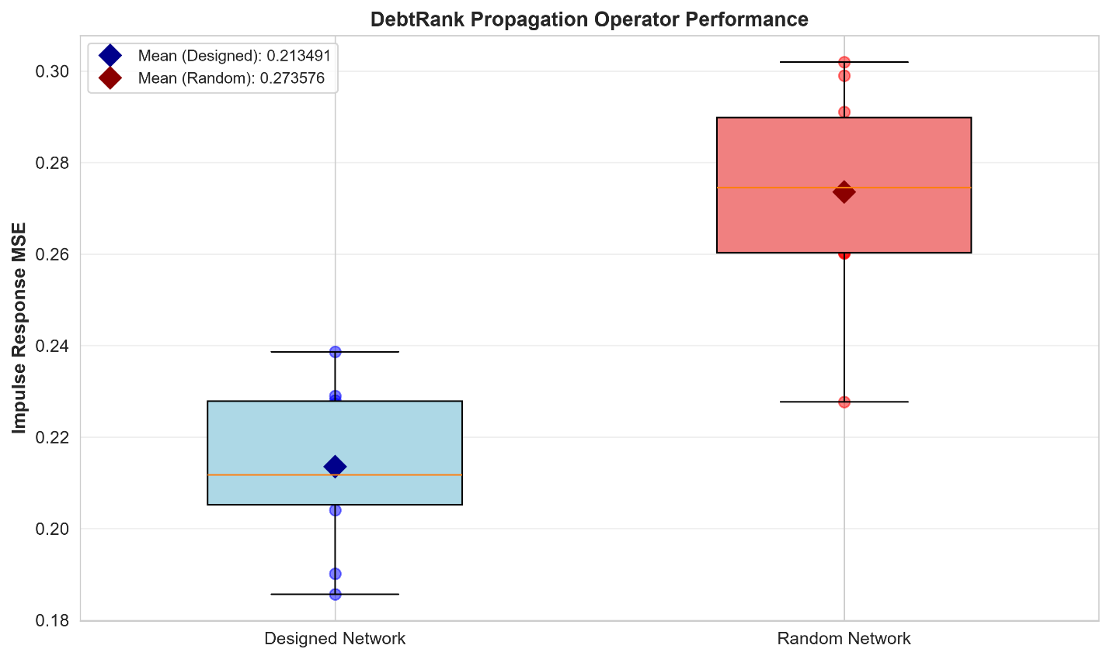
Figure 4.5. DebtRank impulse-response MSE (IR-MSE) for designed versus random networks. Lower MSE is better.

4.7 Summary of key quantitative findings
Table 4.6 — Consolidated results
Method | Metric | Designed | Random | Data-supported statement
VAR+DY | AUC-ROC | 0.4998 | 0.5007 | Chance on both network types
CoVaR | AUC-ROC | 0.5982 | 0.7025 | Above chance on both; 0.1043 lower on designed
GNN | AUC-ROC | 0.2658 | 0.3639 | Below chance on both
DebtRank | IR-MSE | 0.2135 | 0.2736 | 22.0% lower MSE on designed
Four quantitative findings follow directly from the data: (1) only 15.4% of directed edges are recoverable from the lag channel; (2) VAR+DY is at chance on both network types; (3) CoVaR is above chance but weaker on designed networks; (4) GNN is below chance on both network types; (5) DebtRank IR-MSE is 22.0% lower on designed networks.
Insert Figure 4.4 here.
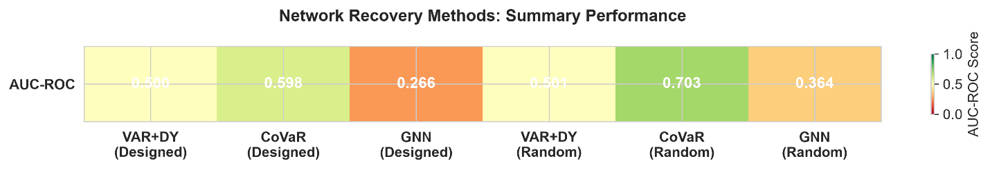
Figure 4.4. Summary AUC-ROC heatmap for VAR+DY, CoVaR, and GNN on designed and random networks.

5. Discussion

5.1 Summary of principal findings
This benchmark evaluated whether three recovery estimators—VAR+Diebold–Yılmaz (VAR+DY), CoVaR, and a Graph Attention Network (GNN)—could recover the directed edge structure of a financial network from observational time-series data, and whether the recovered graphs preserved cascade dynamics when used as inputs to DebtRank. The design crossed two network topologies, five data volumes, and two noise levels, giving 20 configurations and 100 experiments.
Four findings frame the interpretation. First, the direction-identifiability diagnostic showed that only 15.4% of the designed network’s 39 directed edges are recoverable from the lag channel at the tested sample sizes. This is a structural ceiling on lag-based recovery, not an estimator-specific failure. Second, VAR+DY performed at chance on both network types (AUC-ROC 0.4998 designed, 0.5007 random), and its classification metrics confirmed predict-all behaviour at the optimal threshold. Third, CoVaR was the only recovery estimator above chance on both network types (AUC-ROC 0.5982 designed, 0.7025 random), but it was systematically weaker on the designed network and produced sparse, partial predictions. Fourth, the GNN produced below-chance AUC-ROC on both network types (0.2658 designed, 0.3639 random), despite high AUPRC (0.5490 designed, 0.5352 random), an AUC/AUPRC divergence that we report but do not fully resolve. Finally, DebtRank’s IR-MSE was 22.0% lower on designed networks than on random networks (0.2135 vs. 0.2736), the only metric on which the designed topology outperformed the random topology.
Together, these results indicate that network recovery from this DGP is constrained by the weak mapping between the true adjacency and the observable lag structure. That constraint disproportionately affects lag-based methods, while tail-dependence and propagation-based approaches capture different and complementary aspects of network structure.

5.2 The direction-identifiability ceiling
The direction-identifiability diagnostic is the most consequential result because it sets an upper bound on what any lag-based estimator can recover. In the DGP, the true adjacency enters both the contemporaneous copula correlation and the VAR(1) lag matrix. However, the stationarity rescaling that keeps the process economically plausible attenuates the lag-matrix contribution. The lag-1 autocorrelation is high, but the decay rate is low, so the directed signal from the true adjacency is heavily diluted in the lag channel.
This explains why VAR+DY sits at chance on both network types. Its AUC-ROC values are within sampling noise of 0.50, and its classification behaviour—recall equal to 1.0, precision approximately equal to the positive base rate, and F1 equal to the predict-all baseline—is the statistically rational response to a near-zero lag signal. The result should not be read as an implementation failure. It is a predictable consequence of the DGP and sample sizes tested. It also explains why VAR+DY is insensitive to network type: the recoverable fraction of edges is governed by lag attenuation, not by whether the true network is designed or random.
The methodological implication is that benchmarks of lag-based recovery should report a direction-identifiability diagnostic before interpreting estimator performance. Without such a diagnostic, chance-level results can be misattributed to estimator deficiencies rather than to the fundamental limits of the data-generating process.

5.3 CoVaR’s tail-dependence advantage and directional blind spot
CoVaR was the only recovery estimator above chance on both network types. This is consistent with its design: CoVaR measures tail dependence, and the DGP embeds contemporaneous dependence through the copula correlation. Unlike the lag channel, the contemporaneous dependence is not attenuated by stationarity rescaling, so CoVaR has access to a stronger and more stable signal.
However, CoVaR was systematically weaker on designed networks than on random networks. We interpret this as a consequence of CoVaR’s directional blindness. CoVaR captures undirected tail dependence: if two institutions are strongly coupled, CoVaR flags an association regardless of whether the true edge runs in one direction or the reverse. The designed network has an asymmetric, directionally weighted edge structure, so a direction-blind measure conflates true directed edges with their reverses. The random Erdős–Rényi network is more symmetric, so the penalty for ignoring direction is smaller. This explains why CoVaR performs better on random networks despite the designed network having more edges and a higher positive base rate.
The classification metrics reinforce this interpretation. CoVaR was the only estimator producing sparse predictions, with recall 0.5208 on designed networks and 0.4661 on random networks. Its precision exceeded the base rate in both network types, and its F1 exceeded the predict-all baseline. CoVaR is therefore genuinely discriminating, but its discrimination is based on an undirected signal. For applications that require direction—such as counterparty exposure mapping or macroprudential targeting—CoVaR’s recovered graph should be interpreted as an association graph, not a directed exposure graph.

5.4 The GNN anomaly: below-chance recovery and AUC/AUPRC divergence
The GNN result is the most surprising and the most cautionary. Its mean AUC-ROC was below 0.50 on both network types, indicating that its edge rankings were systematically anti-correlated with the true adjacency. This is stronger than simple underperformance: an AUC below chance means the ranking is inverted, not merely noisy.
Several explanations are plausible. The training set may be too small for the GAT to learn generalisable edge structure; the architecture may be mismatched to the DGP because node features are noisy KRI series that are weakly informative about edge direction; or the threshold optimisation may be unstable. We do not resolve the exact mechanism here. The below-chance result is, however, consistent across both network types and both noise levels, which suggests a systematic issue rather than random variation.
The AUPRC results add complexity. Despite below-chance AUC-ROC, the GNN’s AUPRC was well above the positive-class baseline. This divergence is unusual but possible: AUPRC is sensitive to the top of the ranking, so a model can concentrate a few true edges at very high scores while mis-ranking the rest of the distribution. That pattern would produce high precision at low recall and high AUPRC, while depressing AUC-ROC. We report the divergence for transparency but do not use it to claim successful recovery. For comparative claims, we rely primarily on AUC-ROC because it is threshold-independent and interpretable relative to the 0.50 chance line. The GNN results should be treated as a red flag requiring further investigation before graph neural networks are recommended for this task.

5.5 DebtRank propagation: designed advantage despite imperfect edge recovery
DebtRank was evaluated on a different axis: IR-MSE against a reference cascade. Its IR-MSE was 22.0% lower on designed networks than on random networks. This is the only metric on which the designed topology outperformed the random topology.
This result is important because it shows that edge-level recovery metrics and propagation accuracy need not agree. DebtRank’s cascade dynamics depend on the directed, weighted structure of the network—not merely on edge presence. The designed network encodes asymmetric, economically motivated edge weights, so even an imperfectly recovered graph can preserve aggregate propagation pathways. Random networks have a more homogeneous topology, so a graph that captures overall density may still miss the specific pathways that drive cascades.
The implication is that evaluations of network recovery should include propagation-based metrics when the downstream use case is systemic risk monitoring or stress testing. A graph that scores poorly on edge-level AUC-ROC can still produce useful cascade forecasts if it captures the right aggregate propagation structure. Conversely, a graph that scores well on edge recovery may produce poor cascade forecasts if the recovered edges are not the ones that drive contagion.

5.6 Implications for theory and practice
For theory, the study shows that network recovery is not a single problem but a family of problems, each with its own identifiability constraints. Lag-based recovery is constrained by the strength of the lag signal; tail-dependence-based recovery is constrained by direction blindness; graph neural networks are constrained by sample size and architecture–DGP mismatch. No single method dominates across all metrics. Theoretical work should explicitly model the mapping from the true network to observable data and characterise the conditions under which each method is identifiable.
For practice, the results offer concrete guidance. If the goal is to identify undirected association, CoVaR is the best-performing method in this benchmark. If the goal is to forecast cascade dynamics, DebtRank on a designed or propagation-aware graph is preferable, even when edge-level recovery is imperfect. VAR+DY should not be used for network recovery when the lag signal is weak; its chance-level performance is a predictable consequence of the DGP. GNNs should be applied with caution and require further validation before being recommended for financial network recovery.
The designed-versus-random comparison also has a practical interpretation. Designed networks are harder to recover at the edge level for direction-blind methods but easier to propagate accurately because their cascade-relevant structure is more pronounced. Random networks are easier to recover at the edge level for CoVaR and GNN but harder to propagate accurately. The choice of recovery method should therefore depend on the downstream task.

5.7 Limitations and future research
Several limitations should be acknowledged. The DGP is a simplified representation of financial networks: a VAR(1) process with Student’s t-copula tail dependence captures fat tails, contemporaneous dependence, and lagged spillovers, but it does not include non-stationarity, regime switching, or non-linear dependence. Future work should test these methods on more realistic DGPs.
The direction-identifiability diagnostic was performed at the PRT level. Recoverability may differ at the KRI level, and future work should replicate the diagnostic at multiple levels of aggregation. The GNN results are based on a single architecture and training procedure; alternative architectures, training regimes, and larger sample sizes should be explored. The study used five replications per cell and two noise levels; larger replication counts would provide tighter confidence intervals. The propagation metric was computed on a single reference cascade; multiple cascade scenarios would strengthen the DebtRank comparison. Finally, the study used observational data only. Incorporating auxiliary information such as regulatory disclosures or market-based exposures could improve both edge-level and propagation-level accuracy.

6. Conclusion
This study provides a controlled benchmark of network recovery methods against known ground truth. The results are sobering. Lag-based recovery with VAR+DY operates at chance because the directed signal is largely absent from the lag channel at the tested sample sizes. CoVaR captures undirected tail dependence and is the only recovery estimator above chance, but it cannot recover direction and is therefore weaker on asymmetric designed networks. The GNN, in the configuration tested, produces below-chance edge rankings and an unresolved AUC/AUPRC divergence. Only DebtRank’s propagation accuracy shows a clear advantage for the designed network, suggesting that cascade dynamics can be more robust to edge-level recovery errors than edge-level metrics alone would imply.
The practical takeaway is that no single method is sufficient for all network recovery tasks. Method choice should be driven by the downstream application: CoVaR for undirected association, DebtRank or propagation-aware methods for cascade forecasting, and VAR+DY only when the lag signal is known to be strong. Direction-identifiability diagnostics should become a standard pre-analysis step in network-recovery studies, and evaluations should report propagation-based metrics alongside edge-level metrics. By reporting negative and anomalous results transparently, this study contributes to a more honest and nuanced understanding of the limits and possibilities of network recovery from observational data.

